Contents

**1.** **Create the ASP.NET MVC core Web APP project.** 2

**2. Add code to “Azure DevOps Repo”.** 4

# **Create the ASP.NET MVC core Web APP project.**

1. Open Visual Studio 2022 in Admin mode.
2. Select Visual Studio , then click “Create a new project” from Right hand.
3. Select ASP.NET Core Web App (Model-View-Controller) and click Next button.

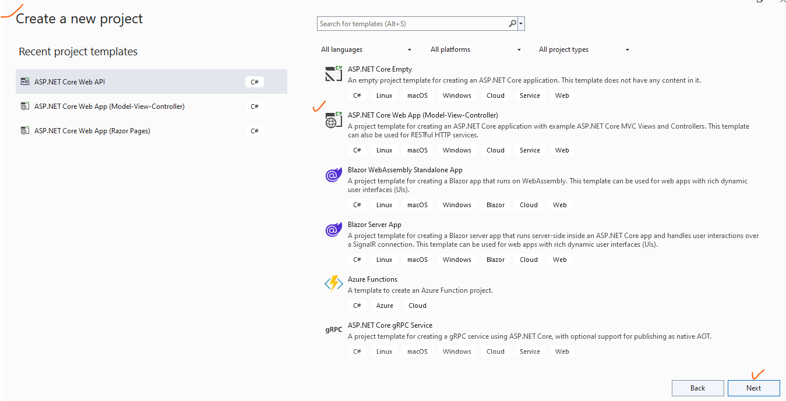

1. A screenshot of a computer

   Description automatically generatedProvide the Project path and Project and Solution name.
2. Additional setting, selecting the .NET Framework.

***Please note*** *that both .NET application and Azure Application Service must be same .NET framework, otherwise publishing will fail. In this demo selected the .NET Framework 6.0.*

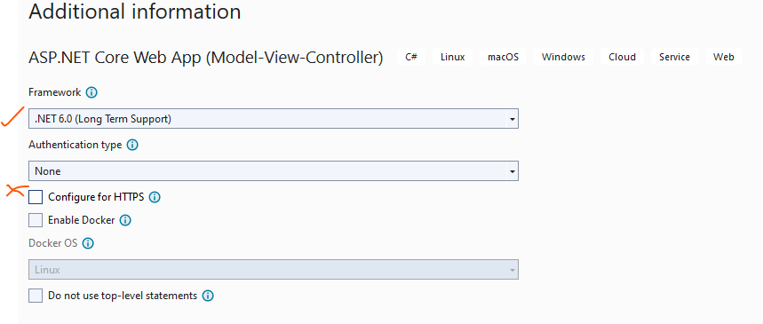

1. Then click “Create” button. VS will create the MVC application.

Below is the default folders and Solution structure.

Please note that. Up to this level only App has been created.

Code not configured to any Source Code. We have options to add the source code to either GitHub or Azure DevOps.

# **2. Add code to “Azure DevOps Repo”.**

1. Create MVC Core Application as mentioned above.
2. Prerequisites, first need to create a <https://dev.azure.com/> DevOps free account.
3. Open Visual Studio on Admin mode
4. Before adding to the Application, it looks below.

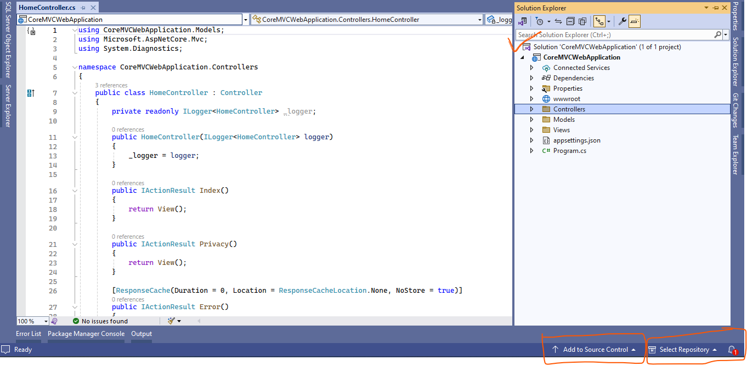

1. Click “Add to Source Control” option
2. 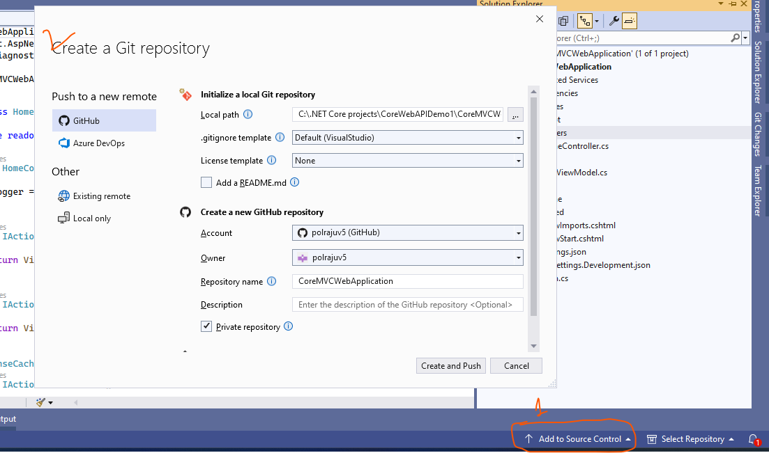It will populate the below window. There are two options to store the information 1. GitHub. 2. AzureDevOps.
3. In this demo we are using AzureDevOps.
4. 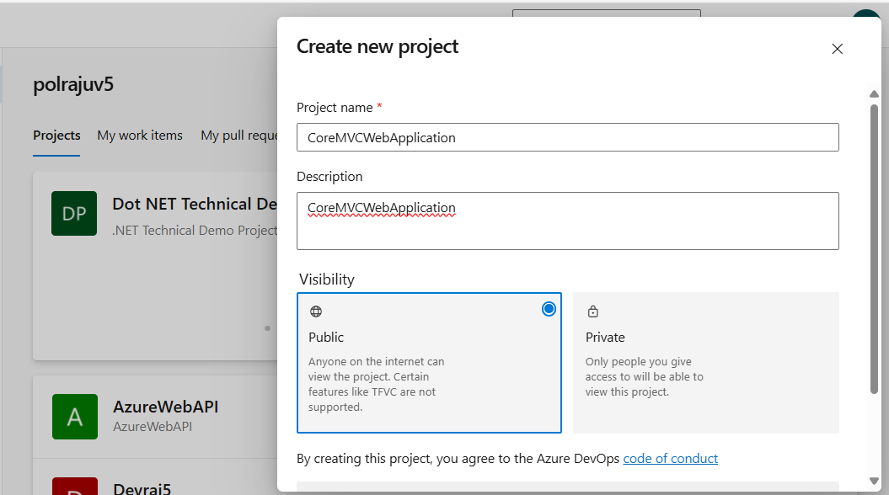To add the code into the Azure DevOps, we must create a New Project in Azure DevOps portal like below.

Click “**Create**” Button.

1. It will create a new project with the required options. See the below image for more information.

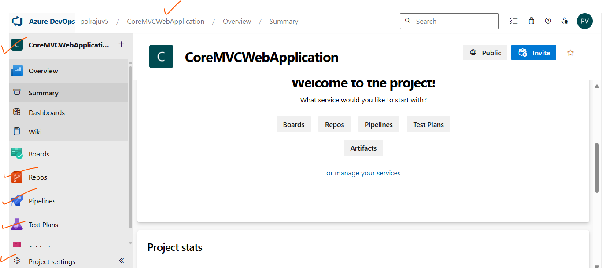

1. Now time to add the VS code into Select AzureDevOps. Go to Visual Studio.

Click the button, “Add to Source Code”, it will show two options like above.

Now we have to choose “Azure DevOps” then it will ask to enter the AzureDevOps details.

Then select the newly created **PROJECT** name. in this case “**CoreMVCWebApplication**”.

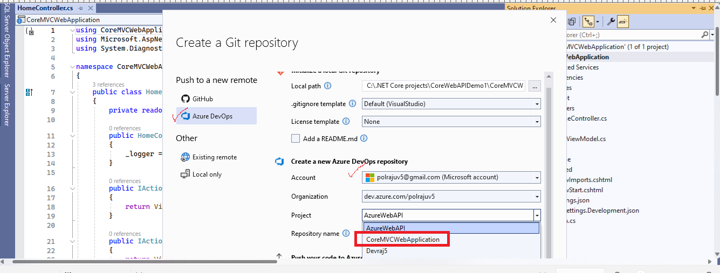

1. Need to enter the Repo Name at the bottom of the screen , give whatever name you prefer. I gave “RepoCoreMVCWebApplication”.
2. Click “Create and Push” button, it will 2-3 minutes to move the code to Azure DevOps.

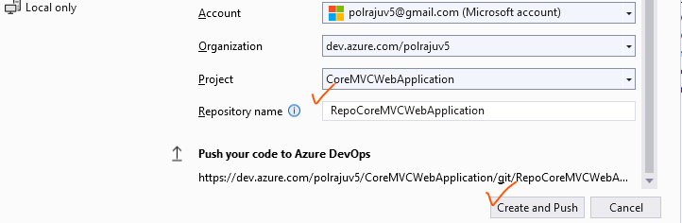

1. It will create a Repo and show the below changes in Visual Studio.

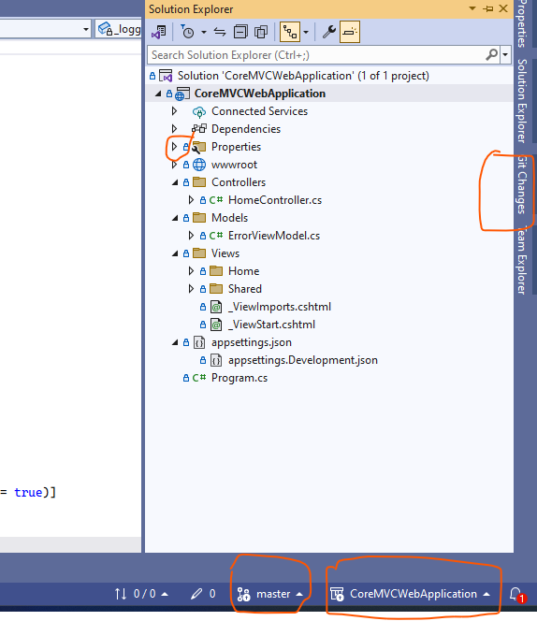

1. Now we must push the code to Repo. Click the push, then “Sync”

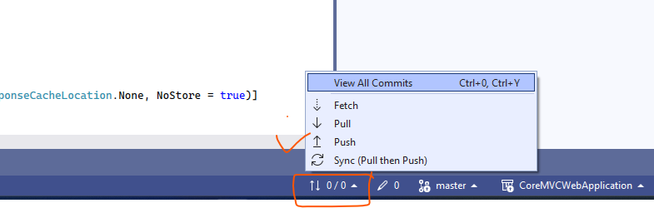

1. Need to login to Azure DevOps portal and Select the Repo… where our changes are created.

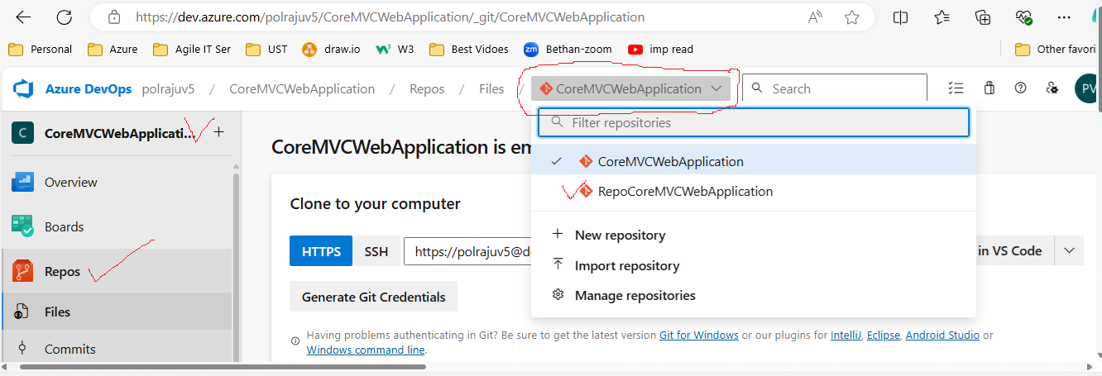

1. A screenshot of a computer

   Description automatically generatedVisual Studio settings / Repo should match with Azure DevOps.
2. Like below we can see the commits or changes.

